*-- Total Revenue: The sum of the total price of all pizza orders,,*

*with cte as*

*(select sum(total_price) from pizza_sales)*

*select * from cte;*

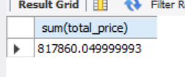

-- Average Order value: The average amount spent per order, calcualted by dividing the total revenue by the total number of orders;

select sum(total_price)/count(distinct order_id) as Avg_amount from pizza_sales;

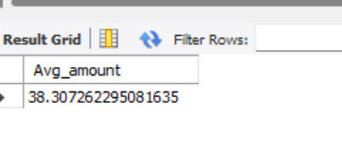

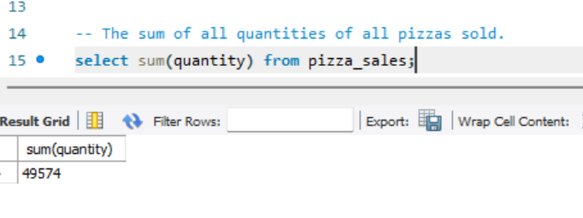

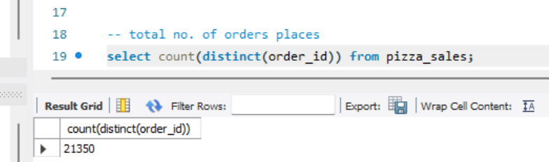

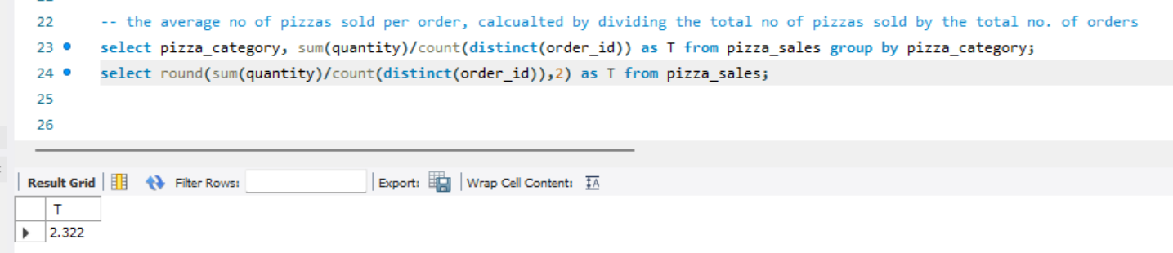

select * from pizza_sales;

-- Daily Trend for Total Orders

SELECT Datename(dw, order_date) AS Day_Name, COUNT(DISTINCT order_id) AS Total_Orders

FROM pizza_sales

GROUP BY Datename(dw, order_date) order by Day_Name desc;

-- Monthly Trend for Total Ordrs

SELECT FORMAT(Order_date, 'MMMM') AS Month, COUNT(DISTINCT order_id) AS Total_Orders

FROM pizza_sales

GROUP BY FORMAT(Order_date, 'MMMM');

-- or

SELECT datename(month, Order_date) AS Month, COUNT(DISTINCT order_id) AS Total_Orders

FROM pizza_sales

GROUP BY datename(month, Order_date);

-- percentage of sales by pizza category;

SELECT

ROUND(SUM(total_price), 1) AS Total_price,

round(SUM(total_price)*100 / (select sum(total_price) from pizza_sales),2) AS Percentage_Sales,

pizza_category

FROM

pizza_sales

GROUP BY

pizza_category;

-- Percentage of sales by Pizza_size

SELECT

ROUND(SUM(total_price), 1) AS Total_price,

round(SUM(total_price)*100 / (select sum(total_price) from pizza_sales),2) AS Percentage_Sales,

pizza_size

FROM

pizza_sales

GROUP BY

pizza_size

order by pizza_size desc;

-- Top/Bottom sellers by revenue, total quantity, and total orders;

-- Total Revenue

select top 5 pizza_name, sum(total_price) as Total_Revenue

from

pizza_sales

group by pizza_name

order by Total_Revenue desc;

select top 5 pizza_name, sum(total_price) as Total_Revenue

from

pizza_sales

group by pizza_name

order by Total_Revenue asc;

select top 5 pizza_name, sum(quantity) as Quantity

from

pizza_sales

group by pizza_name

order by Quantity desc;

select top 5 pizza_name, sum(quantity) as Quantity

from

pizza_sales

group by pizza_name

order by Quantity asc;

select top 5 pizza_name, count(distinct order_id) as Orders

from

pizza_sales

group by pizza_name

order by Orders desc;

select top 5 pizza_name, count(distinct order_id) as Orders

from

pizza_sales

group by pizza_name

order by Orders asc;